Date: January 19, 2021
Contact: Jim Bellamy 419.267.1267 jbellamy@NorthwestState.edu

NSCC NAMES TODD HERNANDEZ
AS EIGHTH PRESIDENT IN COLLEGE’S HISTORY

ARCHBOLD, OHIO – On January 15, the Northwest State Community College Board of Trustees named Todd Hernandez as their next president, succeeding the tenure of President Michael Thomson. NSCC Board of Trustees Chair Joel Miller noted the Board “confirmed Dr. Thomson’s request to alter our contract with him to facilitate spending more time with his family. He has asked that he complete his contract with us March 31, 2021, and we signed an agreement today honoring that request. With the full agreement of the Board, we signed a contract with (Executive Vice President) Todd Hernandez to become the eighth President of Northwest State Community College.”

Regarding the transition and its timing, Dr. Thomson noted “As with many things related to our current public health situation, the pandemic reveals the need for change, and accelerates that very change. Life is precious, and I desire to be with my family as soon as it is safe to do so. The Board and I had a contract timetable of December, 2021. We are starting a transition process now in anticipation of the time when we can travel more freely.” The Board lauded Dr. Thomson for his service, and embraced the succession model for naming the College’s new President.

Todd Hernandez is a veteran of the United States Navy, and brings considerable experience in advanced manufacturing and information technology from the private sector. Hernandez has served in a variety of capacities at NSCC over the past 11 years – most recently as EVP, where he was responsible for overseeing the daily operations of the College. He has also led the charge for the College’s impressive workforce development branch, which includes Custom Training Solutions. Hernandez, who was one of two finalists in the Presidential search back in 2018, noted that Dr. Thomson has been a blessing for the College, the community, and for him on a personal level.

Reflecting on his time with Dr. Thomson, Hernandez said, “I would like to thank President Thomson for his leadership these past three years. He brought new ideas and a strategic focus on mission to our campus. During his Presidency, we have seen marked improvements in organizational culture, community engagement, enrollment management, and fiscal sustainability. On a personal note, I truly appreciate the mentorship he has provided and I am grateful to call him friend.

As Hernandez begins to look forward, he noted “NSCC is on a good path. We are midway through year one of a very good three year strategic plan. The strategic plan will continue to transform NSCC into a more learner-centric institution while providing investments in academic excellence, workforce development, improved culture, and community engagement.” A search for the new Executive Vice President will begin immediately.

Hernandez holds a Master of Information Systems Management degree from Keller Graduate School of Management, and a Bachelor’s of Science in Electrical Engineering Technology from DeVry Institutes of Technology (Columbus). He is currently completing his Doctorate of Information Technology from Walden University. He is married and has two children.

###

Northwest State Community College is an accredited two-year, state-assisted institution of higher education that has served northwest Ohio since 1969. Northwest State is committed to providing a quality, affordable education with personal attention and small class sizes. The College offers associate degrees with numerous transfer options, short-term certificate programs, and workforce training programs designed to meet the needs of local businesses and industries. For more information, visit NorthwestState.edu or call 419.267.5511.

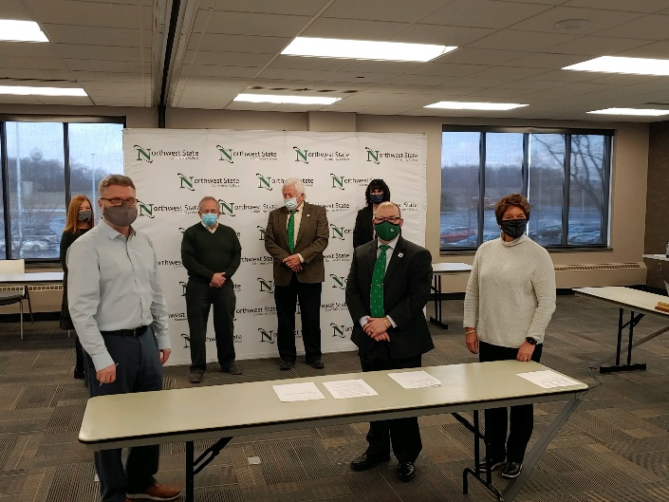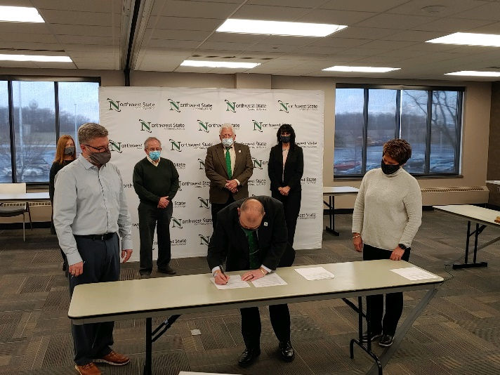
Todd Hernandez was named by the Board of Trustees as the eighth president of Northwest State Community College at today’s special board meeting, held at the NSCC Archbold campus. Hernandez will succeed retiring president Dr. Michael Thomson.

