Short Reports on Advancing Ethnic Studies

Contact: Kenneth Monteiro, Acting Director,
César Chávez Institute
College of Ethnic Studies
Telephone: 415.495.7579
Email: monteiro@sfsu.edu

Ethnic Studies Contributes to College Students’ Success

San Francisco – Preliminary data from a San Francisco State University evaluation study indicate that successfully passing Ethnic Studies courses is strongly associated with improved performance of college students across the campus.

“Ethnic Studies has demonstrated benefit for all students – students of color and White students, Ethnic Studies majors and other majors, as it exposes them to analytical thinking, cultural competencies and applications relevant to their lives and future careers in a manner necessary for navigating a multi-cultural, rapidly evolving nation,” said Dr. Kenneth Monteiro, Dean of the College of Ethnic Studies.

According to highlights of the data compiled by the college’s Division of Institutional Analytics (Sutee, please provide most precise designation) (Link or as we’ve done place the data at the end of the document. I prefer the latter. A couple of journalists suggested not using url or other attachments but providing all info in one place):

- Ethnic Studies Majors in general graduate at approximately 20 percent higher rates than non-Ethnic Studies Majors
- Ethnic Studies Majors graduate at a rate higher than majors from any of the other colleges at the university.
- Students who enrolled in at least one Ethnic Studies class graduated at a higher rate than students who took no Ethnic Studies classes.
- Students in majors other than Ethnic Studies (e.g. arts, business, humanities, health, or sciences) who took Ethnic Studies classes graduate at a much higher rate than their peers in their major who did not take Ethnic Studies classes.

“These preliminary findings underscore the value and need for Ethnic Studies classes for all students,” said Dr. Kenneth Monteiro, Dean of the College of Ethnic Studies. “Ethnic Studies is proving to better prepare students to learn the rest of the curriculum, increasing the probability of students to achieve in any of their chosen professional aspirations and positioning them to best serve themselves and their communities.

In addition, Dean Monteiro added, a recent independent evaluation study of a partnership between the San Francisco Unified School District and the College of Ethnic Studies by Stanford University researchers demonstrated that their Ethnic Studies in the high school curriculum was associated with improved grade point averages and other student achievement indicators for students of all ethnicities. (Link)

“If we want to improve graduation rates and better prepare new leaders for the twenty first century, then we need to pay attention to the data,” said Monteiro.

In the late 1960’s the seeds planted by the longest student strike in U. S. history led by the Black Student Union and the Third World Liberation Front at, then, San Francisco State College resulted in the establishment of the nations’ first College of Ethnic Studies in 1969. Those seeds continue to bear a bountiful harvest, as indicated by the Stanford study and the data presented here. Despite the controversy that ethnic studies programs spark for some, these and other data clearly demonstrate that a well designed academically based Ethnic Studies program prepares students to succeed academically, professionally, and socially enabling them to make valuable contributions to the community, the country and our democracy.

The return on investment in Ethnic Studies programs is one that certainly is worth making for the benefits it brings to the possibilities of the 21st Century.

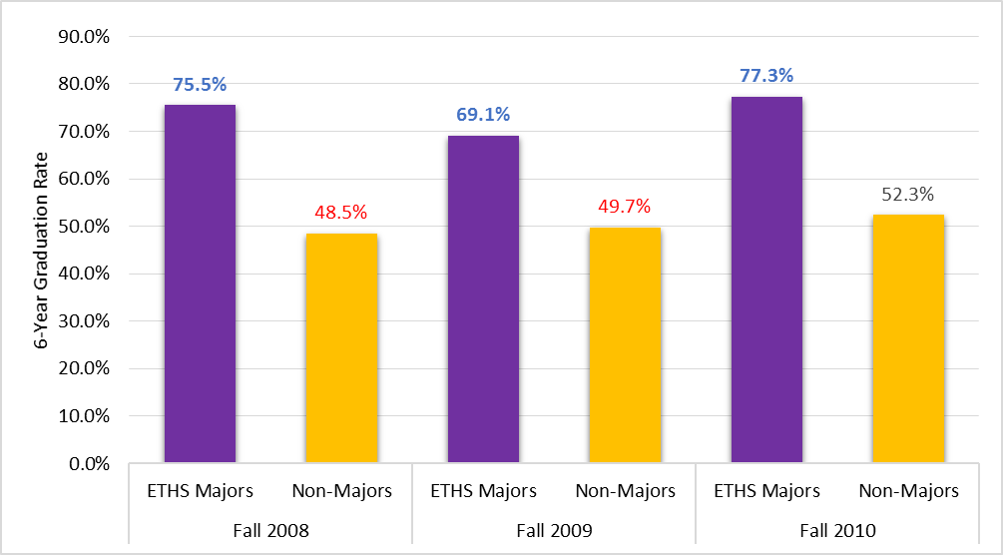

6-year graduation rates: Ethnic Studies Majors vs. Non-Ethnic Studies Majors
Ethnic Studies majors graduated at much higher rates (approximately 20 percent higher than Ethnic Studies majors)

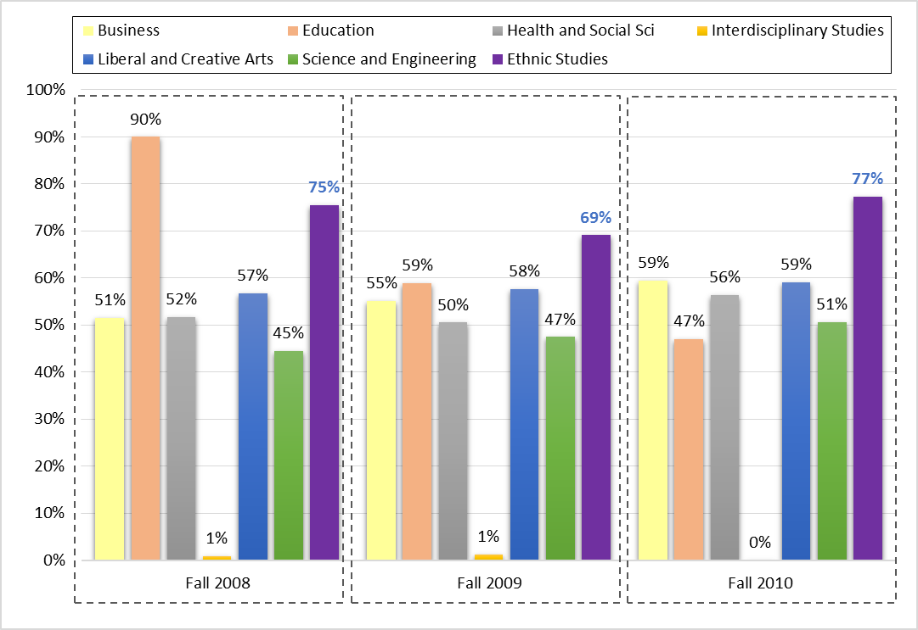

6-year graduation rates: Ethnic Studies Majors vs. Non-Ethnic Studies Majors (by College)
Ethnic Studies Majors graduated at higher rates than non-majors from other colleges (with the exception of the fall 2008 cohort)

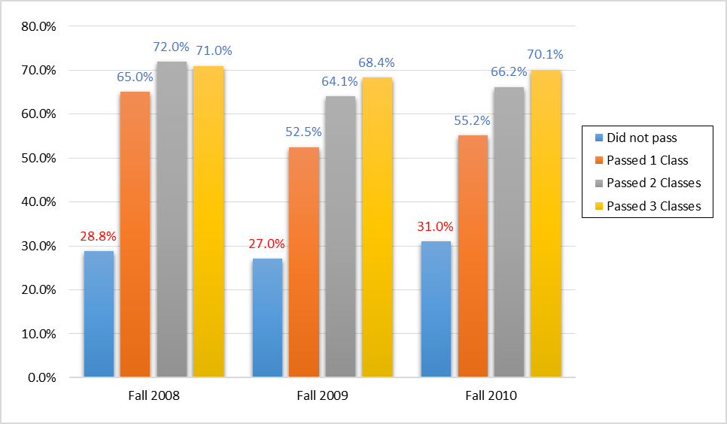

6-year Graduation Rates by Ethnic Studies Classes for Non-Ethnic Studies Majors
Students who enrolled, but did not pass any Ethnic Studies classes graduated more than 20 percent lower than students who passed

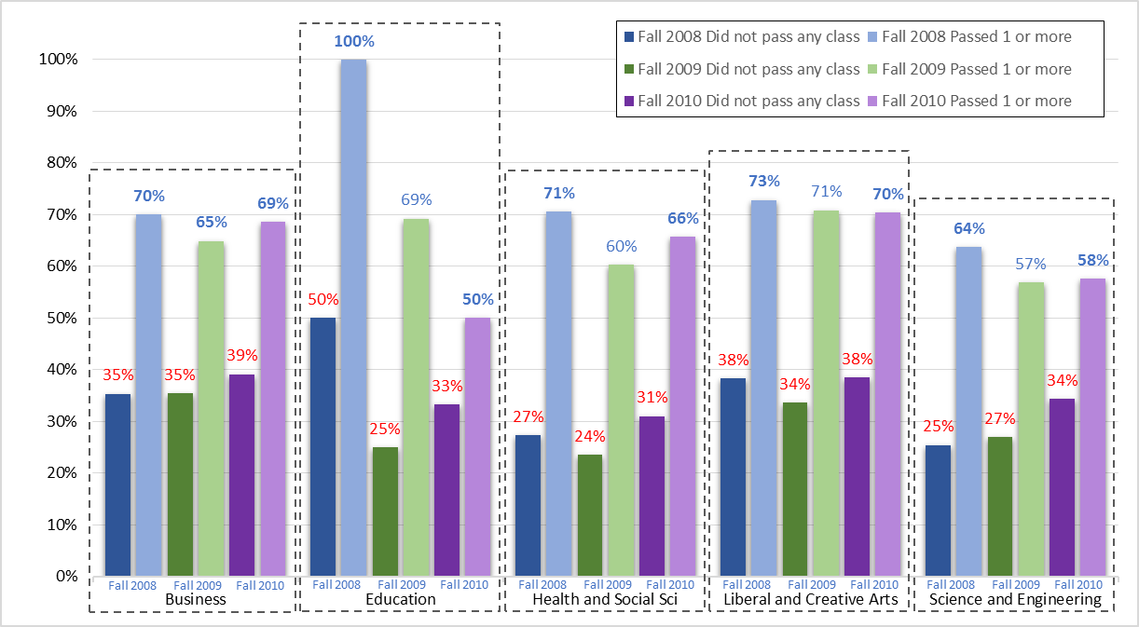

Comparison of 6-year Graduation Rates by Ethnic Studies Classes for Non-Ethnic Studies Majors.
Students who did not pass Ethnic Studies classes graduated at significantly lower rates (nearly half) across all colleges

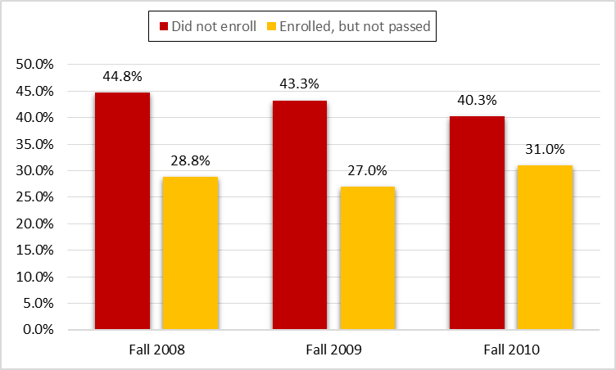

6-year Graduation Rates: Zero Ethnic Studies Class
Students who did not earn credits from Ethnic Studies class, students who failed the class graduated at much lower rates than those who did not enroll.

